EVENT FLYER

QUEENSLAND CHAPTER

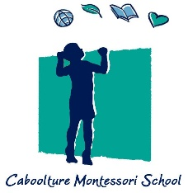
CABOOLTURE MONTESSORI SCHOOL
Tuesday 20 June 2017 at 2:30 pm

The Queensland Chapter is pleased to offer members the opportunity to visit the Caboolture Montessori School.
Located on a 10 acre rural site five minutes north of the Caboolture CBD, the Caboolture Montessori School offers a Montessori education program for children from age 15 months through to Year 6.
The Caboolture Montessori School's mission is to educate individuals in their school and community by implementing the Montessori philosophy and methodology. Their aim is to prepare a developmentally appropriate environment to encourage our children to responsibly and respectfully engage in their learning journey.
A new classroom building features a variety of learning environments focusing on the importance of the surrounding environment and collaborative learning. The building was designed in collaboration with staff and students through a series of workshops and has been designed for future expansion as the school grows.
GUEST SPEAKER: YVONNE RINALDI, Principal, Caboolture Montessori School

Yvonne’s experience working with children as a medical technologist in South Africa highlighted her interest in education and learning. Join fellow members to hear Yvonne talk about how Montessori entered her life, her passion for learning and the journey that has led to Caboolture Montessori. With Architect Rachel Towill, share their experience in planning and constructing this new building.

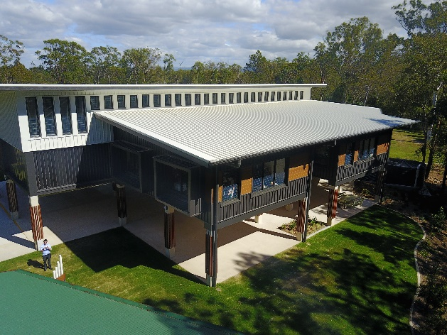
Where: Caboolture Montessori School
200 Old Gympie Rd, Caboolture
When: Wednesday 26 April 2017
Time: 2:30 pm sharp
Cost: Members $20 + GST
Non-members $30 + GST
This event is proudly sponsored by Furnware

