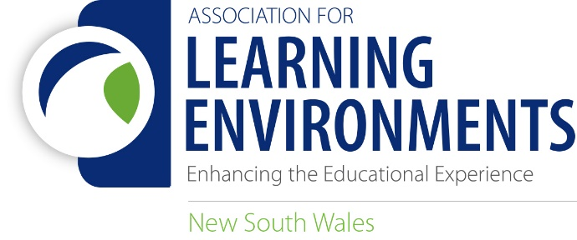

NSW CHAPTER LEARNING ENVIRONMENTS AWARDS 2020

Expression of Interest Request for Jury Members

The purpose of Learning Environments Australasia NSW Chapter (LEA NSW) Awards is to enhance the profile of design and building development as it applies to all educational facilities across the Region.

The LEA NSW Awards reflect the philosophy of our organisation. The projects awarded will best demonstrate the effectiveness of comprehensive planning and design relating to improving student learning.

We are looking for educators, architects, building consultants, facility planners and anyone involved in educational facilities to become jurors for the awards. We aim to utilise a spread of expertise, judging experience and gender in selecting jurors for each judging panel.

Judging is based on submissions only (no site visits required) and will be done via the Awards Portal.

Previous award winners and previous jury members are strongly encouraged to nominate as jurors for this year’s awards.

Based on the number of entries and the spread across the eight categories, we expect to utilise two jury panels of three members each. We also propose to appoint a Panel Chair, who will be responsible for producing a short Jury Citation for each Winning and Commended entry. This year the number of entries to be assessed by each panel will be approximately 10 submissions. We also will be arranging an opportunity at the end of the Jurying process for each panel to finalise their selections and provide input into the Citations.

The LEA NSW Awards will be presented in late November this year (date and format TBC).

Until all Jury Expressions of Interest/Nominations and the number of entries received in each Category are reviewed, we are unable to guarantee an individual a position on any judging panel. Notification of acceptance will occur after 16 September 2019. Note – Students are not eligible to participate on Jury panels.

If you would like to express your interest in being a juror on an award panel for the 2020 LEA NSW Awards, you are invited to complete the nomination form below, and provide a single A4 page CV/Summary of Experience, including any previous judging experience to: lea.nsw.awards@gmail.com by Sunday, 20th September, 2020.

Key Dates: Jury Members are required to be available for Jury briefings, review and deliberations during this time:

- Nomination Form & CV Summary due: 20th September
- Jury Briefing (via email): 23rd September
- Jury Review: 30th September - 25th October
- Awards Presentation – TBC

Please contact me if you have any questions regarding your nomination.

Rachael Drayton
NSW Awards Coordinator
0422 493 088
lea.nsw.awards@gmail.com

NOMINATION FORM - JUROR 2020 LEA NSW AWARDS

Name:
Email:
Mobile:
Organisation/Company:
Are you an LEA Member: □Yes □ No □ Not sure?

Have you previously been a LEA Awards or LEA NSW Awards Jury Member?
□ Yes □ No Year/s:

Which of the following best describes your experience:
□ Educator □ Architect □ Building consultant
□ Facility planner □ Other?

Additional Considerations
Are you intending to submit an entry in the LEA NSW Awards or are you involved in a project that is to be submitted? □Yes □ No Category/Categories:
Note: It is possible for you to be a Juror if your firm has submitted for an award but you cannot judge the same category.

Do you have a past LEA Award winning project/s? We strongly encourage previous award winners to become jurors for this year’s awards:
□Yes □ No Category/Categories & Year/s:

If you have previously served as a juror on the LEA Awards process, are you prepared to act in the role of Panel Chair? □Yes □ No

IMPORTANT
If you are selected to form part of a panel:
- You will be asked to review the list of entries for that panel and confirm that you do not have a conflict of interest with any of the entries.
- Please sign here to confirm that you undertake to keep the information related to the entries and the results of the awards confidential within your panel prior to the announcement of the award winners.

Name (printed)

Signature Date

Please email this nomination form with your one A4 page of CV/Summary of experience to
Rachael: lea.nsw.awards@gmail.com by 20th September 2020. Thank you for your nomination.

